MACHINE LEARNING (BCS602)
REPORT ON
“Implementing a Decision Tree Regressor from Scratch for Heart Disease Prediction”
Submitted in partial fulfilment of the requirements for the 6th Semester
Bachelor of Engineering in
INFORMATION SCIENCE AND ENGINEERING
Submitted by
ABHAY SINGH 1BI23IS003
AMOGH BHAT NAGRI 1BI23IS012
ARYAN PILLAI 1BI23IS015
ASHWINI KUMAR 1BI23IS016

Under the Guidance of
Dr. Jayasheela C S
Associate Professor
Dept of ISE, BIT


BANGALORE INSTITUTE OF TECHNOLOGY
K R Road, V V Pura, Bengaluru-560004
DEPARTMENT OF INFORMATION SCIENCE AND ENGINEERING
2025-26

TABLE OF CONTENTS
TABLE OF CONTENTS 2
CHAPTER 1 2
INTRODUCTION 2
1.1 Project Overview 3
1.2 PROBLEM STATEMENT 4
1.3 OBJECTVIES OF THE PROJECT 4
CHAPTER 2 5
ALGORITHMS USED 5
2.1 CART Algorithm 5
CHAPTER 3 7
MODEL ARCHITECTURE AND DESIGN 7
3.1 OVERALL ARCHITECTURE 7
3.2 WORKFLOW OF THE SYSTEM 9
CHAPTER 4 10
IMPLEMENTATION 10
4.1 DATA PREPROCESSING IMPLEMENTATION 10
4.2 DECISION TREE IMPLEMENTATION 10
4.3 NODE STRUCTURE 11
4.4 SECURITY SCANNING AND LOGIC 11
4.5 VISUALIZATION 12
CHAPTER 5 13
MODEL WORKFLOW AND PREDICTION PROCESS 13
Workflow of Prediction System 13
CHAPTER 6 15
RESULTS AND PERFORMANCE ANALYSIS 15
Types of Testing Performed 15
Results 15
CHAPTER 7 18
ADVANTAGES AND LIMITATIONS 18
Advantages 18
Limitations 19
CHAPTER 8 20
FUTURE ENHANCEMENTS 20
CHAPTER 9 21
CONCLUSION 21
CHAPTER 10 22
REFERENCES 22
PRESENTATION 23

ABSTRACT

The Heart Disease Prediction System is a machine learning project developed to implement a Decision Tree Regressor completely from scratch using the CART (Classification and Regression Trees) algorithm. The system is designed to predict heart disease risk using clinical and medical attributes obtained from the UCI Cleveland Heart Disease dataset. Unlike traditional machine learning implementations that depend on pre-built libraries such as Scikit-learn, this project manually implements the complete decision tree construction process including data preprocessing, impurity calculation, recursive tree generation, prediction traversal, and performance evaluation.
The preprocessing stage includes handling missing values, one-hot encoding of categorical features, feature normalization, and train-test splitting to prepare the dataset for model training. The core model uses Mean Squared Error (MSE) reduction as the splitting criterion to determine the best feature thresholds during tree construction. The project is implemented using Python, while NumPy, Pandas, and Matplotlib are used for numerical computation, dataset handling, and visualization respectively.
The system also includes multiple visualization and evaluation modules such as Actual vs Predicted analysis, residual error distribution, feature importance analysis, tree depth vs error comparison, and decision tree visualization. Model performance is evaluated using metrics such as Mean Squared Error (MSE) and R² score to analyze prediction accuracy and generalization capability. The project demonstrates the practical implementation of machine learning algorithms, data preprocessing techniques, recursive model construction, and performance analysis within a single educational and interpretable system.

CHAPTER 1

INTRODUCTION

Heart disease is one of the leading causes of death worldwide and remains a major challenge in the healthcare sector. Early prediction and diagnosis of heart-related diseases can significantly improve patient treatment and reduce mortality rates. Traditional diagnosis methods often involve costly medical procedures, laboratory testing, and specialist interpretation, making early detection difficult in many situations. With the rapid growth of Machine Learning, predictive models can now assist in analyzing medical data and identifying potential health risks more efficiently.
Decision Trees are among the most interpretable and widely used machine learning algorithms for prediction and classification tasks. They provide a tree-like structure of decisions that is easy to understand and visualize, making them especially suitable for healthcare applications where interpretability is important. However, most modern implementations rely heavily on pre-built machine learning libraries, which often hide the internal working principles of the algorithms.
The Decision Tree from Scratch project was developed as an educational and practical implementation of the CART (Classification and Regression Trees) algorithm for heart disease prediction. The system manually implements the complete decision tree regression process without using pre-built Decision Tree libraries such as Scikit-learn. The project includes data preprocessing, handling missing values, feature encoding, feature normalization, recursive tree construction, prediction traversal, model evaluation, and visualization.
The application uses the UCI Cleveland Heart Disease dataset containing various clinical attributes such as age, cholesterol level, blood pressure, chest pain type, and maximum heart rate. The model predicts heart disease risk by recursively splitting the dataset using Mean Squared Error (MSE) reduction as the splitting criterion. The project also includes visualization modules to analyze prediction accuracy, residual error distribution, feature importance, and tree structure.
The project combines machine learning concepts, mathematical implementation, data preprocessing techniques, recursive algorithms, and visualization methods into a single interpretable and educational system.

1.1 Project Overview
The Decision Tree from Scratch project is designed to predict heart disease risk using a manually implemented CART Decision Tree Regressor. The system processes medical and clinical attributes from the dataset and generates prediction values representing heart disease severity or risk probability.
The application performs multiple stages of machine learning workflow including dataset preprocessing, tree construction, prediction generation, performance evaluation, and visualization analysis.

Data Preprocessing
The preprocessing stage prepares the dataset before training the model. The preprocessing operations include:
- Handling missing values using median and mode imputation
- One-hot encoding of categorical attributes
- Feature normalization using Min-Max scaling
- Manual train-test dataset splitting
Decision Tree Construction
The Decision Tree model is implemented completely from scratch without using built-in Decision Tree libraries. The model performs:
- Recursive binary splitting of the dataset
- Mean Squared Error (MSE) calculation
- Best threshold and feature selection
- Recursive node generation
Evaluation and Visualization
The system evaluates model performance using regression evaluation metrics and visualizations. These include:
- Mean Squared Error (MSE) analysis
- R² score evaluation
- Actual vs Predicted comparison graphs
- Residual error distribution

1.2 PROBLEM STATEMENT
Heart disease diagnosis often requires detailed medical analysis, laboratory testing, and specialist interpretation, which may not always be accessible or affordable. Existing healthcare prediction systems frequently rely on complex machine learning libraries that hide the internal implementation details of algorithms, reducing educational understanding of how predictive models actually function.
There is a need for a simplified and educational machine learning system that demonstrates the complete implementation of a Decision Tree algorithm from scratch while also providing meaningful prediction and visualization capabilities for heart disease risk analysis.
The project aims to solve this problem by developing a fully manual CART-based Decision Tree Regressor capable of performing heart disease prediction using clinical data while clearly demonstrating the internal working principles of machine learning algorithms.

1.3 OBJECTVIES OF THE PROJECT
The main objectives of the project are:
- To implement a Decision Tree Regressor completely from scratch using the CART algorithm
- To avoid the use of pre-built Decision Tree machine learning libraries
- To preprocess medical datasets using encoding, scaling, and missing value handling techniques
- To perform recursive binary splitting using Mean Squared Error reduction
- To generate heart disease risk predictions using clinical attributes
- To evaluate model performance using MSE and R² score metrics
- To visualize model behaviour using graphs and decision tree diagram

CHAPTER 2

ALGORITHMS USED

The project uses Machine Learning concepts along with the CART (Classification and Regression Trees) algorithm to perform heart disease prediction. The implementation is developed completely from scratch without using pre-built Decision Tree machine learning libraries. Python is used as the primary programming language, while additional libraries are used for numerical computation, dataset handling, and visualization.
Component | Technology Used
Programming | Python
Core Algorithm | CART
Dataset | Pandas
Splitting Criterion | Mean Squared Error
Feature Scaling | Min-Max
Python
React.js is used for building the frontend user interface. It provides component-based architecture and enables dynamic rendering of data.

2.1 CART Algorithm
The project uses the CART (Classification and Regression Trees) algorithm for building the Decision Tree Regressor. CART is a binary tree-based algorithm that recursively splits the dataset into two branches at each node based on feature thresholds.
The algorithm evaluates multiple possible splits and selects the split that minimizes prediction error and improves data purity. In this project, CART uses Mean Squared Error (MSE) reduction as the splitting criterion for selecting the best feature and threshold. The main objectives of the project are:
- Calculate impurity using Mean Squared Error
- To avoid the use of pre-built Decision Tree machine learning libraries
- Select the split with maximum impurity reduction
- Stop tree growth based on stopping conditions such as maximum depth and minimum sample size

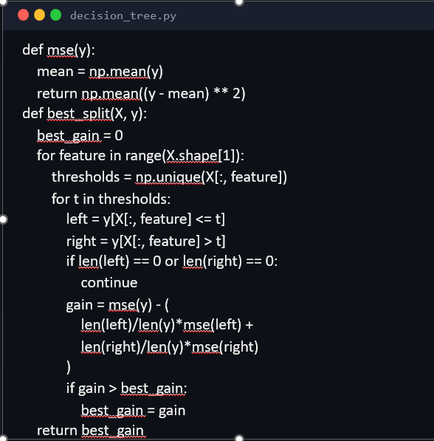

Mean Squared Error
Mean Squared Error is used as the impurity measurement for selecting the best split during tree construction. Lower MSE values indicate better grouping of similar target values.
The algorithm calculates the average squared difference between actual values and the mean prediction value within a node. The split that produces the maximum reduction in MSE is selected during tree generation.
Min-Max Normalization
Min-Max Normalization is used to scale feature values into a range between 0 and 1. This helps maintain consistent numerical ranges across features and improves computational stability during model training.

CHAPTER 3

MODEL ARCHITECTURE AND DESIGN

3.1 OVERALL ARCHITECTURE
The project follows a machine learning pipeline architecture consisting of the dataset layer, preprocessing layer, model construction layer, evaluation layer, and visualization layer. The system processes clinical heart disease data and generates prediction results using a manually implemented CART Decision Tree Regressor.
Dataset Layer
The dataset layer consists of the UCI Cleveland Heart Disease dataset containing multiple medical and clinical attributes such as age, cholesterol level, blood pressure, chest pain type, fasting blood sugar, and maximum heart rate. The dataset acts as the primary input for training and testing the model.
Pre-processing Layer
The preprocessing layer is responsible for preparing the dataset before model training. This layer performs:
- Missing value handling
- One-hot encoding of categorical features
- Min-Max feature normalization
- Manual train-test dataset splitting
These preprocessing operations ensure that the dataset is suitable for decision tree construction and prediction.
Decision Tree Model Layer
The core layer of the project is the manually implemented CART (Classification and Regression Trees) Decision Tree Regressor. The model recursively splits the dataset into smaller subsets using feature thresholds selected through Mean Squared Error (MSE) reduction.
The model performs:
- Recursive binary splitting
- Best feature and threshold selection
- Node generation and traversal
- Prediction generation using leaf node values
Visualization
The visualization layer generates graphical representations of model behaviour and prediction analysis. This includes:
- Actual vs Predicted graph
- Residual error distribution
- Feature importance analysis
- Tree depth vs error graph
- Decision tree visualization
The generated visualizations improve interpretability and help understand the internal working of the model.
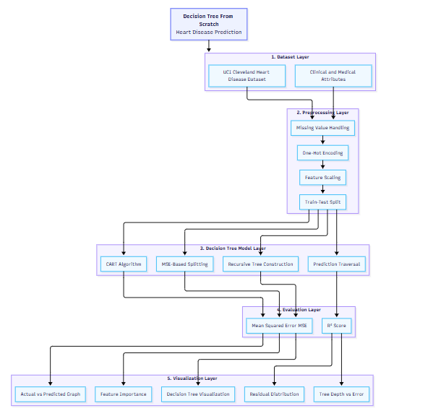

3.2 WORKFLOW OF THE SYSTEM
The workflow of the model is as follows:
- Dataset is loaded into the system
- Missing values are identified and handled
- Categorical features are converted using one-hot encoding
- Numerical features are normalized using Min-Max scaling
- Dataset is manually divided into training and testing sets
- CART algorithm recursively constructs the Decision Tree
- Best feature splits are selected using Mean Squared Error reduction
- Predictions are generated by traversing the tree nodes
- Model performance metrics are calculated
- Visualization graphs and tree diagrams are generated
- Prediction results and feature importance analysis are displayed
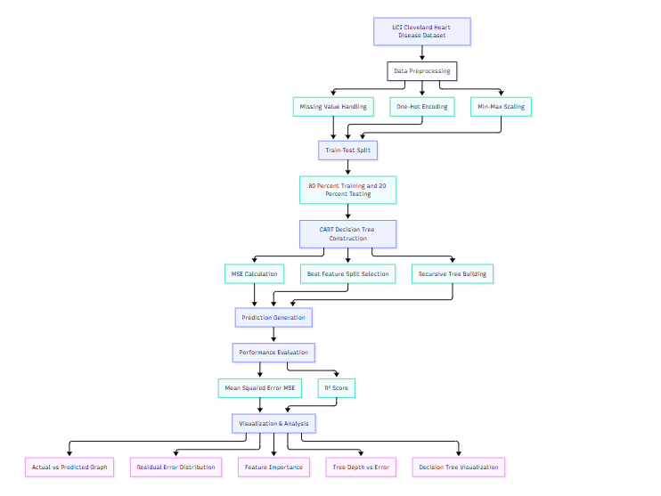

CHAPTER 4

IMPLEMENTATION

4.1 DATA PREPROCESSING IMPLEMENTATION
The project uses the UCI Cleveland Heart Disease dataset for training and evaluating the Decision Tree model. The preprocessing stage is implemented completely using Python, Pandas, and NumPy without relying on external machine learning preprocessing libraries.
The preprocessing module prepares the dataset before model training and ensures that all features are converted into a suitable numerical format.
Main Features
• Missing value handling using median and mode imputation
• One-hot encoding for categorical features
• Min-Max feature normalization
• Manual train-test dataset splitting
• Automatic target column detection
Preprocessing Module Structure
heart_regression/
├── preprocessing.py
├── data_utils.py
├── metrics.py
Main Preprocessing Responsibilities
- Load and validate the dataset
- Detect target column automatically
- Handle missing numerical and categorical values
- Normalize features using Min-Max scaling

4.2 DECISION TREE IMPLEMENTATION
The core Decision Tree Regressor is implemented completely from scratch using the CART (Classification and Regression Trees) algorithm. The implementation does not use Scikit-learn or any built-in Decision Tree libraries.
The model recursively constructs a binary tree structure by selecting the best feature thresholds using Mean Squared Error reduction.
The tree handles:
- Recursive tree generation
- Binary dataset splitting
- MSE impurity calculation
- Prediction traversal
- Feature importance calculation
Decision Tree Module Structure
Heart_regression/
├── tree.py
├── node.py
├── app.py
Main DT Responsibilities
- Build the CART Decision Tree recursively
- Calculate impurity reduction using MSE
- Generate left and right child nodes
- Traverse tree nodes for prediction

4.3 NODE STRUCTURE
The project uses a custom Node structure to represent individual nodes of the Decision Tree. Each node stores information related to feature selection, threshold values, prediction outputs, impurity values, and child node references.
Node Information Stored
- Feature Index
- Threshold Value
- Left child node
- Right child node
Tree Construction Flow
- Dataset enters the root node
- Mean Squared Error is calculated
- Multiple feature thresholds are evaluated
- Child nodes are recursively generated
- Tree growth stops when stopping conditions are reached

4.4 SECURITY SCANNING AND LOGIC
The prediction module generates output values by traversing the trained Decision Tree from the root node to the appropriate leaf node based on feature thresholds.
The evaluation module analyzes model performance using regression evaluation metrics.
Prediction Process
The system checks for:
- Input sample starts at the root node
- Feature value is compared with threshold
- Traversal continues left or right recursively
- Final prediction is obtained from the leaf node
Metrics
The system uses:
- MSE
- R² Score
Performance Includes
The system uses:
- Training and testing error comparison
- Actual vs Predicted analysis
- Overfitting analysis using tree depth comparison

4.5 VISUALIZATION
The project includes multiple visualization modules implemented using Matplotlib to analyze model behaviour and prediction performance.
The visualization system improves interpretability and provides graphical understanding of the Decision Tree model.
Features:
- Actual vs Predicted graph
- Tree depth vs error analysis
- Decision Tree structure visualization

CHAPTER 5

MODEL WORKFLOW AND PREDICTION PROCESS

Module | Purpose
preprocessing.py | Dataset preprocessing and feature transformation
tree.py | CART Decision Tree construction
node.py | Decision Tree node structure
metrics.py | MSE and R² score calculation
visualizaiton.py | Graph generation and analysis
app.py | Main project execution workflow

Workflow of Prediction System
- Heart disease dataset is loaded
- Missing values are handled
- Categorical features are encoded
- Features are normalized using Min-Max scaling
- Dataset is divided into training and testing sets
- CART algorithm recursively constructs the Decision Tree
- Best feature splits are selected using MSE reduction
- Predictions are generated through tree traversal
- MSE and R² metrics are calculated
- Visualization graphs and analysis results are generated

Preprocessing
Missing stage includes:
- Missing value handling
- Feature Scaling
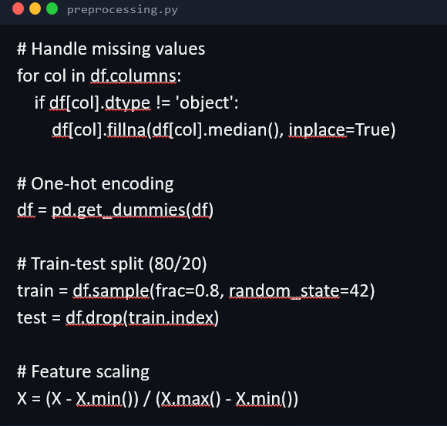
Prediction
The prediction module traverses the Decision Tree recursively to generate output predictions for input samples. The evaluation module calculates:
- MSE
- R² Score
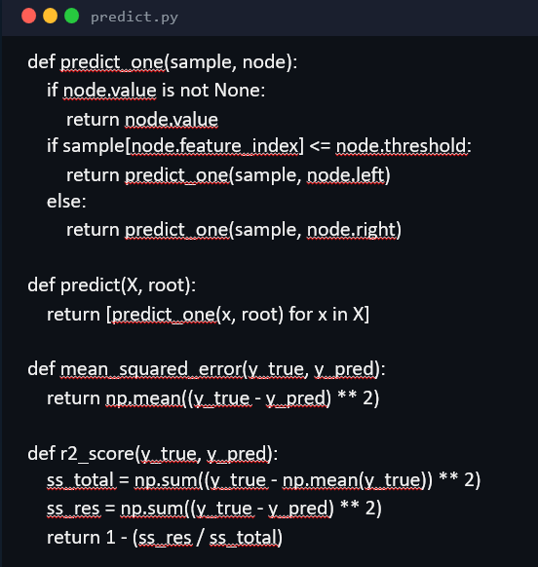

CHAPTER 6

RESULTS AND PERFORMANCE ANALYSIS

Testing was performed to verify the correctness of dataset preprocessing, Decision Tree construction, prediction generation, evaluation metrics, and visualization behaviour of the system.

Types of Testing Performed
- Dataset preprocessing testing
- Missing value handling testing
- Feature encoding and normalization testing
- Decision Tree construction testing
- Recursive prediction traversal testing
- Visualization and graph testing
- Overfitting and depth analysis testing
System succesfully:
- Loaded and preprocessed the heart disease dataset
- Constructed a CART Decision Tree completely from scratch
- Generated heart disease risk predictions
- Calculated Mean Squared Error (MSE) and R² Score
- Visualized the structure of the Decision Tree model

Results
Implemented Decision Tree Regressor achieved the following:
- Training MSE: 0.0619
- Test MSE: 0.1312
- Training R² Score: 0.7504
- Test R² Score: 0.4478
The evaluation results indicate that the model achieved reasonable prediction capability while maintaining interpretability and controlled overfitting through depth limitation and stopping criteria.:

Actual vs Predicted Risk graph
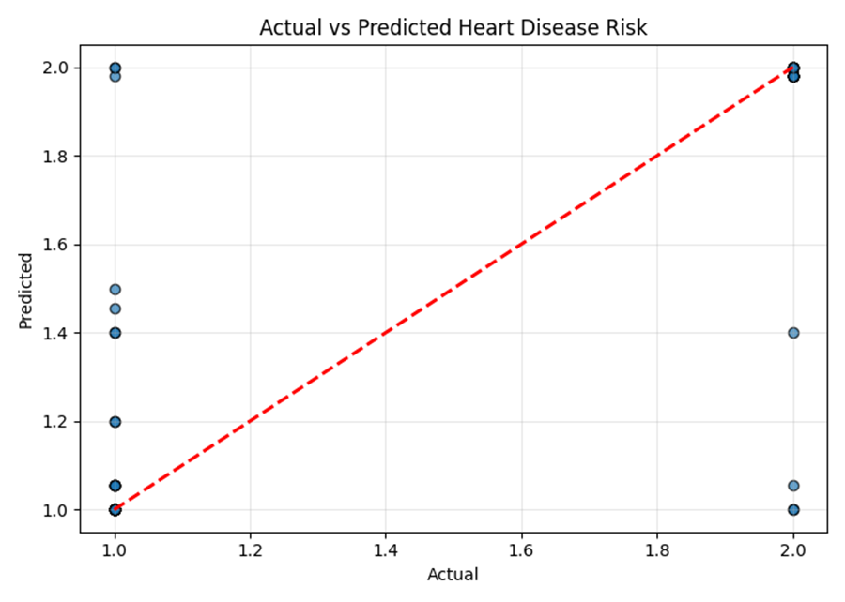

Residual Error Distribution graph
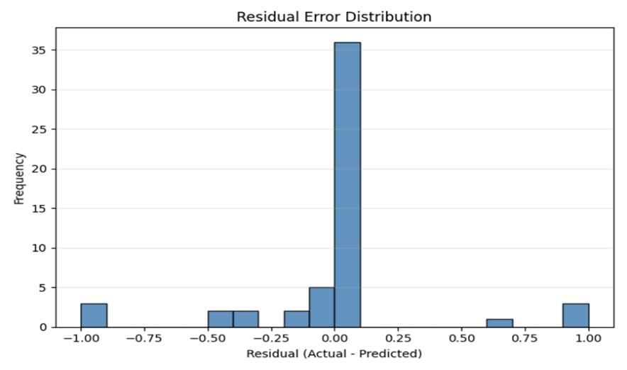

Tree Depth vs Error graph
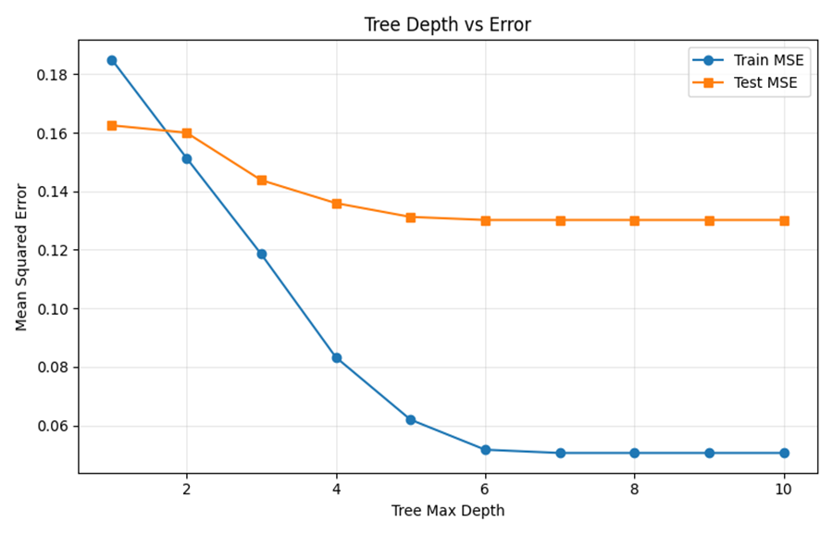

Decision Tree Visualization
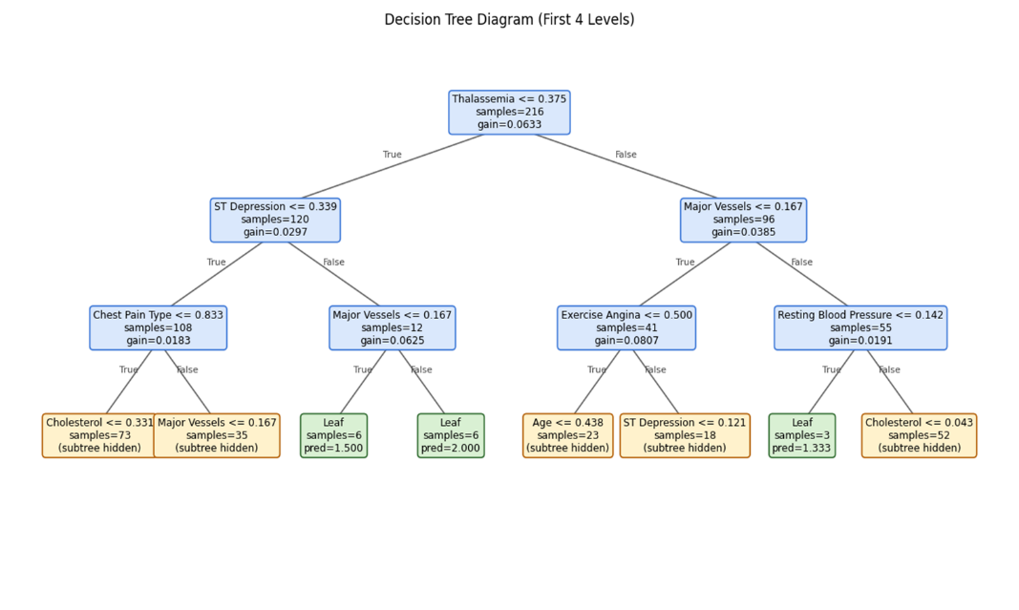

Feature Importance Analysis graph

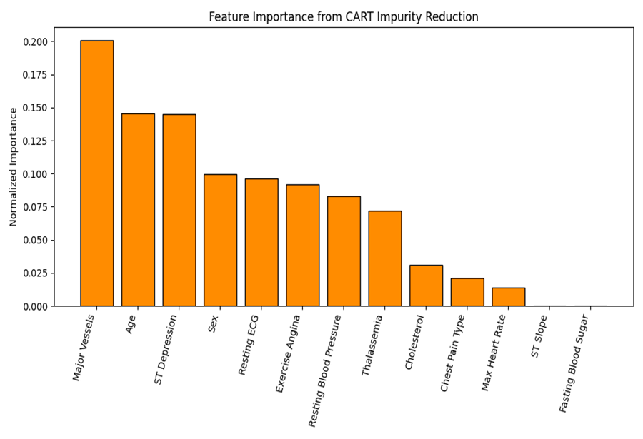

CHAPTER 7

ADVANTAGES AND LIMITATIONS

Advantages

• From-scratch implementation – The project manually implements the complete CART Decision Tree algorithm without using pre-built Decision Tree libraries, improving understanding of machine learning concepts.
• Interpretable model structure – Decision Trees provide a clear and visual representation of how predictions are generated, making the model easier to understand and analyze.
• Educational value – The project demonstrates important machine learning concepts such as recursive tree construction, impurity reduction, preprocessing, and prediction traversal in a simplified manner.
• Effective preprocessing pipeline – The system handles missing values, categorical encoding, feature normalization, and train-test splitting using custom preprocessing logic.
• Visualization support – Multiple graphs and visual outputs help analyze prediction behaviour, feature importance, overfitting, and model performance.
• Lightweight implementation – The project uses only basic Python libraries such as NumPy, Pandas, and Matplotlib without relying on heavy machine learning frameworks.
• Feature importance analysis – The model identifies important medical features contributing to heart disease prediction, improving interpretability of results.

Limitations

• Small dataset size – The UCI Cleveland Heart Disease dataset contains a limited number of records, which restricts model generalization capability.
• Moderate prediction accuracy – The model achieves reasonable but limited prediction performance compared to advanced ensemble learning methods.
• Computationally expensive split search – Evaluating multiple feature thresholds recursively increases computation time for larger datasets.
• Susceptible to overfitting – Deep Decision Trees may memorize training data and reduce generalization performance on unseen data.
• Limited to single Decision Tree architecture – The project does not implement advanced ensemble methods such as Random Forest or Gradient Boosting.
• Basic regression approach – The model focuses on educational implementation and interpretability rather than achieving state-of-the-art prediction accuracy.
• No real-time deployment – The current implementation functions as a standalone machine learning project and is not deployed as a real-time healthcare application.

CHAPTER 8

FUTURE ENHANCEMENTS

The project can be improved further by implementing:
• Random Forest implementation – Multiple Decision Trees can be combined to improve prediction accuracy and reduce overfitting through ensemble learning.
• Advanced pruning techniques – Cost-complexity pruning and post-pruning methods can be implemented to improve model generalization and reduce unnecessary tree growth.
• Cross-validation support – K-Fold Cross Validation can be added to generate more reliable and stable model evaluation results.
• Larger medical datasets – The model can be trained on larger and more diverse healthcare datasets to improve prediction capability and generalization performance.
• Classification-based prediction – The system can be extended to perform heart disease classification in addition to regression-based risk prediction.
• Hyperparameter optimization – Automated tuning of parameters such as tree depth, minimum samples split, and impurity thresholds can improve model performance.
• Real-time prediction system – The project can be converted into a real-time healthcare prediction application where users can enter medical attributes and receive instant predictions.
• Web application deployment – A frontend interface and backend API can be developed to deploy the model as a complete web-based healthcare system.
• Integration of advanced machine learning models – Other machine learning algorithms such as Support Vector Machines, Neural Networks, and Gradient Boosting models can be integrated for performance comparison and hybrid prediction systems.

CHAPTER 9

CONCLUSION

The Decision Tree from Scratch project successfully demonstrates the complete implementation of a CART-based Decision Tree Regressor for heart disease prediction using machine learning concepts and medical dataset analysis. The project provides a simplified and educational approach for understanding the internal working principles of Decision Trees without relying on pre-built machine learning libraries such as Scikit-learn.
The system combines dataset preprocessing, recursive tree construction, Mean Squared Error based splitting, prediction traversal, evaluation metrics, and visualization techniques into a single interpretable machine learning application. The project highlights important concepts related to machine learning algorithms, recursive data structures, regression analysis, feature preprocessing, and performance evaluation.
The implementation achieved reasonable prediction performance on the UCI Cleveland Heart Disease dataset while maintaining model interpretability and visualization clarity. Multiple graphical analyses such as Actual vs Predicted comparison, residual distribution, feature importance analysis, and Decision Tree visualization helped improve understanding of model behaviour and prediction patterns.
The project serves as a strong example of combining mathematical implementation, machine learning concepts, and healthcare prediction systems within a fully manual and educational Decision Tree framework.

CHAPTER 10

REFERENCES

- Python Official Documentation – Used for implementing the complete machine learning workflow and project structure.
- NumPy Documentation – Referenced for numerical computation, array manipulation, and mathematical operations used during tree construction and evaluation.
- Pandas Documentation – Used for dataset handling, preprocessing, missing value treatment, encoding, and data transformation operations.
- Matplotlib Documentation – Referenced for generating graphs, visualization plots, and Decision Tree diagrams.
- UCI Machine Learning Repository – Cleveland Heart Disease Dataset – Used as the primary dataset for training and testing the Decision Tree model.
- CART (Classification and Regression Trees) Algorithm – Referenced for understanding recursive tree construction, binary splitting, and regression tree implementation concepts.
- Decision Tree Learning Concepts – Referenced for understanding impurity reduction, recursive partitioning, and prediction traversal methods.
- Mean Squared Error (MSE) and R² Score Evaluation Metrics – Used for model evaluation and prediction performance analysis.
- Machine Learning Concepts and Regression Techniques – Referenced for understanding preprocessing methods, regression analysis, and model evaluation principles.

PRESENTATION



